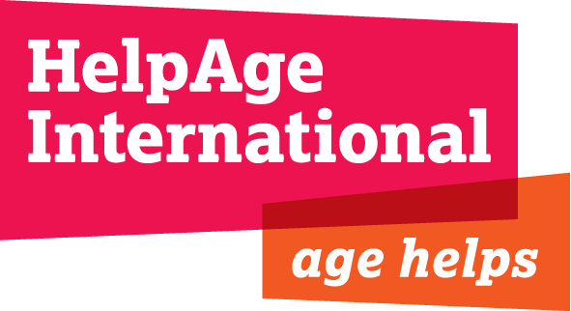

HelpAge International

Ethical Fundraising Policy

Introduction

In determining HelpAge’s ethical fundraising policy, its Board of Trustees is mindful of the need to ensure that the organisation maintains an adequate and sustainable funding base. In accordance with charity law, HelpAge’s Trustees have an obligation to maximise resources for the charity and, in turn, expenditure on activities that benefit the millions of poor older people around the world. Unless there are demonstrable reasons not to, HelpAge would therefore want to explore and enter into all funding relationships that have the potential to further our cause.

That said, it is imperative that we do not accept donations that have the potential to impact negatively on the charity’s integrity or reputation or are in conflict with our cause and values.

The following principles therefore help to guide our fundraising efforts

Principles

- It will not be possible for us to accept donations that are perceived to be detrimental to the interests of our beneficiaries.

- It is important that we assess not only the value, but also the risk that any individual donation could bring to the organization. HelpAge will therefore carefully consider any donation that we feel could put in jeopardy its credibility or reputation

- If requested by a potential donor, we will assess the use of a donor’s identify in our marketing and programming activities on a case by case basis. Likewise, with prior approval, we would be willing for the donor to make reference to their connection with HelpAge in their own communications.

- We would be unable to accept funding that has the potential to constrain us from undertaking our vital advocacy and campaigning activities or programming work, publishing and disseminating information or working in partnership with others. Or that would run the risk of other donors withdrawing their support.

- Fundamental to HelpAge’s work and approach is its equal opportunities policy. HelpAge does not discriminate on any grounds including gender, race, disability, age, nationality, ethnic/national origin, sexual orientation, religious beliefs, marital status, pregnancy, trade union affiliation or any other criteria prohibited by law.

- We understand there are occasions when donors prefer to donate anonymously and this will be accommodated so long as we can have a guarantee that the donation complies with our ethical funding policy

A practical and pragmatic approach

We recognise that these principles are open to interpretation and that it is difficult and, to a certain extent, inappropriate to develop a set of standard criteria for accepting/rejecting donations on an ethical basis. However, based on the above guiding principles, if any doubt is raised about the source of a donation prior to acceptance, the following procedure will be followed:

- Through published information, the nature of the donor’s activities, and its source of funding for charitable giving, will be researched and analysed
- If further information is deemed necessary, we will undertake a formal corporate screening process through a reputable online service provider

Whilst the Board delegates responsibility to the Chief Executive and relevant Departmental Directors for making judgements against the above principles, if a consensus cannot be reached, the decision will be referred to the Board Executive Committee. The Board will also receive an annual report on any donations rejected.

We will also look favourably on donors that are actively putting steps in place to mitigate any past actions that may have contravened the above principles.

