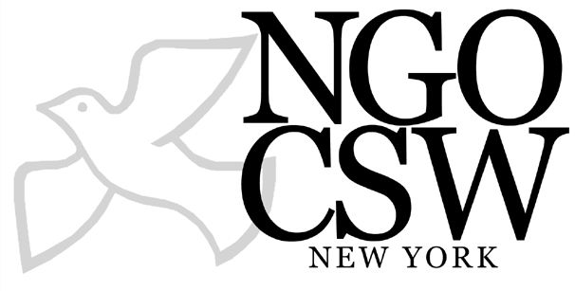
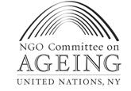

Older women and Beijing: 15 years on

Older women in the Beijing Declaration and Platform for Action
15 years ago, the Beijing Declaration recognised age discrimination as one of the factors contributing to the barriers to women’s empowerment and advancement. Older women were specifically mentioned in the Beijing Platform for Action with regard to their poverty, health, violence against them, obstacles they face in entering the labour market, discrimination at work and as a civilian group particularly affected by armed conflict. Demographic ageing in developed and developing countries and the need for age-disaggregated data were emphasised. Recommendations for government action were made in each of these areas but there were also gaps, including the complete omission of widows and widowhood.

The question remains 15 years later. To what extent have governments and others implemented these actions and to what extent are older women and population ageing priorities for future action?

Older women in the century of ageing
As we enter the second decade of the 21st century, older women continue to live longer than men, are less likely to be married, more likely to live alone and less likely to have access to an income through work in the formal or informal sector.

 | Women | Men
Life expectancy at 60 years 2005 – 2010 | 21 years | 18 years
% living alone at 60 years and over | 19 | 9
% in labour force 60 years and over | 20 | 40

Source: UNDESA, Population Ageing and Development 2009, http://www.un.org/esa/population/publications/ageing/ageing2009chart.pdf

Some issues affecting older women that were recognised in Beijing have risen higher on the global agenda than others. Climate change is now recognised as one of the defining issues of our age yet population ageing, which is also having a profound impact on society and the lives of older women, is being addressed in some countries but barely recognised in the public policy of others.

Economic migration is currently a key issue, yet the impact it has on older women who are often left to bring up young grandchildren without anticipated remittances, is rarely recognised. 10 years into the Millennium Development Goals, older women remain invisible in programmes, targets and indicators designed to achieve them, despite the key role they play in their own and their families’ development. Data disaggregated by age and sex is extremely limited, even in some of the key areas affecting women such as violence and HIV infection rates, where most available data stops at age 49.

However, there have been positive developments too. The 2002 Madrid International Plan of Action on Ageing (MIPAA) has helped raise ageing and its gender implications at the national and international level. Older women’s rights have been highlighted with the decision by the Committee on the Elimination of Discrimination Against Women to develop a general recommendation on the rights of older women.

Social protection is increasingly being recognised as pivotal to reducing poverty and social exclusion. Non-contributory pensions that help to overcome gender inequality are gaining ground as affordable, effective social protection mechanisms. On health, the WHO’s recent report on women and health paid particular attention to older women’s health. The role of older women as carers is being increasingly recognised in the response to HIV and AIDS.
As we look ahead, there are two major opportunities to ensure the empowerment and advancement of older women are better protected and their contributions supported and recognised:
- in determining the focus of the new UN gender entity and
- in the debate around the MDGs and development post-2015.

Older women in the Beijing+15 review
It is against this backdrop that the responses to a questionnaire sent out by the Division for the Advancement of Women are so disappointing. A review of 121 national responses to the questionnaire showed patchy and inconsistent recognition of, and attention to, older women.

Older women and poverty
Attention to older women was greatest in descriptions of measures to reduce women’s poverty with 30 of the countries including information on social security (pensions) and other social protection measures for older women or older people more broadly. There is a general recognition that women are more at risk of poverty in old age than men but only five countries provided poverty data that was disaggregated by age and sex and two countries by age.

Older women and health
There was mention of the impact on women of caring for older people in a handful of responses but older women’s own health was mentioned in only 19 of the responses reviewed. A second questionnaire for African countries developed by the Economic Commission for Africa asked specifically whether countries had any health interventions for older women. Of 40 responses reviewed, 17 answered yes but the majority did not go on to give details of what these interventions were.

Older women and violence
A similar picture emerges on violence against older women. Older women remain invisible in responses to violence against women with only four countries mentioning violence against older women. A further seven include information on elder abuse more broadly.

Older women and employment
Eleven of the 121 responses reviewed included measures to encourage and support employment of older women. This is disappointing when more and more older women are either having to or choosing to continue working into old age to support themselves and their families.

Data disaggregated by age and sex
What is particularly noticeable is the lack of data disaggregated by age and sex, despite this being a specific recommendation in the Beijing Platform for Action. Only two countries reviewed recognised the lack of such data as a problem and one made a commitment to collect it.

Looking ahead: the next 15 years
A questionnaire of this nature cannot cover every government action aimed at empowering and advancing women. What it does tell us, however, is that older women are a low priority for most countries and that governments have a long way to go to meet their commitments under Beijing towards them. Finally, and perhaps most disturbingly at a time when populations have already aged considerably in some countries and are ageing rapidly in others, only six responses reviewed recognised ageing and its impact on women as a future priority.

Such recognition is imperative if policies, including those on health, employment, social security and climate change, and the resources allocated to implement them, are to be adapted to meet the needs of everyone, including older women.

Written by Bridget Sleap, Rights Policy Adviser, HelpAge International, bsleap@helpage.org
www.helpage.org

February 2010

WHO, Women and health: today's evidence tomorrow's agenda, 2009 http://www.who.int/gender/women_health_report/en/index.html
Questionnaire available at http://www.un.org/womenwatch/daw/beijing15/questionnaires/questionnaire%20english.pdf
Responses reviewed 6-12 January 2010, available at http://www.un.org/womenwatch/daw/beijing15/national-level.html#res

