HE President of the Republic of Indonesia
Dr H. Susilo Bambang Yudhoyono
Istana Negara
Jl Veteran 16
Jakarta Pusat
Indonesia
Jakarta/London February 2013

RE: Population ageing and the post 2015 agenda

Dear President Yudhoyono,

We thank you for taking leadership in the post 2015 development process. It is, as you have mentioned, an important opportunity to have a new strong global development framework.

One of the most overlooked issues of development today is population ageing.

In Indonesia, we have seen strong commitment by the Ministry of Social Affairs (MoSA) as well as BAPPENAS and TNP2K to address this challenge. HelpAge International and Yayasan Emong Lansia have worked closely with these agencies for many years to support older people in Indonesia.

We have also seen strong commitment from ASEAN to address population ageing in its 2011-2015 Strategic Framework for Social Welfare and Development, which has older people as a priority area of concern along with children and people living with disability.

Population ageing is a challenge for economic and social development all over the world and South East Asia is the epicentre of this challenge. For example, one out of four Indonesians will be an older person by 2050.

Today, around 11% of the global population is aged more than 60; and by 2050 this will have increased to 22%. This is a historic and unprecedented demographic transition that needs our immediate attention. The post 2015 process cannot miss the opportunity to do so.

(continues)

We would like to support your efforts, as President of Indonesia and co-chair of the UN High Level Panel, to ensure that population ageing is properly addressed in the discussions around a new global framework.

We want now to respectfully suggest a dedicated discussion on population ageing at the meeting of the High Level Panel in Bali in March.

We can facilitate the participation of a variety of stakeholders, including older people, experts on ageing, demographers, High Level Panel members and youth groups, as they will be part of the world’s 2 billion people over 60 in 40 years’ time, in this discussion.

We thank you once again your strong leadership in the post-2015 process and look forward to the proposed event.

Yours Sincerely,
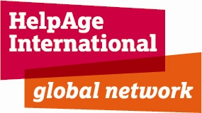
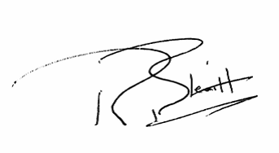

Richard Blewitt

CEO of HelpAge International
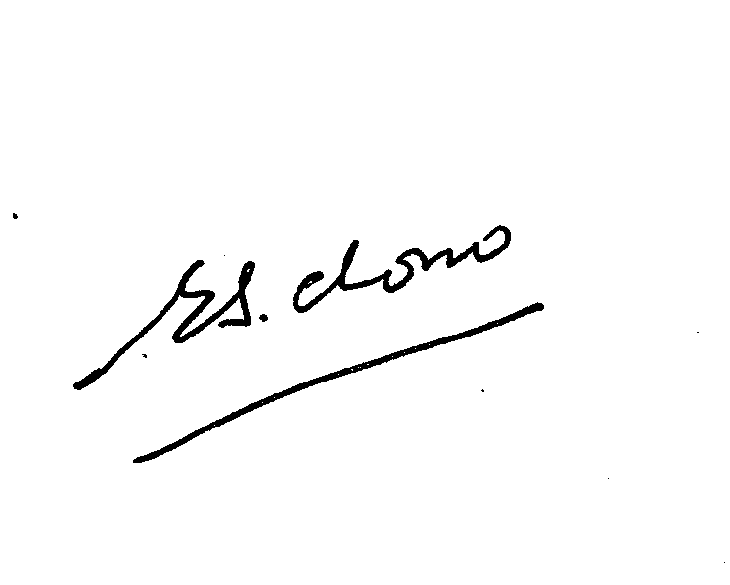

Eva Sabdono
Executive Director of Yayasan Emong Lansia Indonesia

